**Assignment 4**

1. Install Flutter, make a project by “**Flutter create projectname**” and then run app by **“flutter run”** and take screenshot.

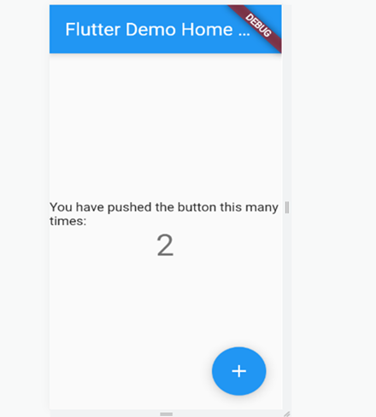

1. To make a function that take a number as parameter, and print the table of that number

Code:

void main(){

var a = 2;

table(a);

}

void table(int a){

for( var i = 1; i<=10; i++){

print("${a}x${i}=${a*i}");

}

}

Output:

1. List lst = [2,4,6,8,9];

Make a function that takes a number as parameter and divide that parameter to every element in the list

Code:

void main(){

var b = 2;

number(b);

}

void number(b){

List lst = [2,4,6,8,9];

for(var j in lst){

print(j/b);

}

}

Output:

1. **Make a function for printing mark sheet then Make a list of at-least 5 names and another list of their marks, and print the mark sheet of all of them.**

**Code:**

void main() {

List students = ["Rizwan", "Bilal", "Ibad", "Shahryar", "Osama"];

List marks = [400, 350, 400, 390, 340];

Marksheet(students, marks);

}

void Marksheet(student, marks){

print ('\t\tMarksheet');

int total = 500;

for (int i = 0; i < student.length; i++) {

num per = marks[i] / total * 100;

print("\n ${student[i]} secured a total of ${marks[i]} marks and $per %");

}

}

1. Make a function in class and then call it outside class.

**Code:**

void main() {

var obj = abc();

obj.welcometodarts();

}

class abc {

void welcometodarts() {

print("Welcome To Darts");

}

}

1. Print your name in a sentence using classes.

Code:

void main() {

var obj = Name();

print(obj.name);

}

class Name {

var name = "My name is Rizwan";

}

1. Make a constructor that requires your name, age, education and then print that.

main() {

Developer me = Developer(age: 24, name: "Rizwan", education: "BSCS");

me.sayMyName();

}

class Developer {

//properties definition

int age;

String name;

String education;

//constructor

Developer({required this.name, required this.age, required this.education});

//method

void sayMyName() {

print("My age is $age");

print("My name is $name");

print("My name is $education");

}

}

Output:

1. **Write a Code using inheritance**

**Code:**

void main() {

Dog myPuppy = Dog();

myPuppy.setLegs(4);

myPuppy.setWeight(4.5);

myPuppy.breathe();

myPuppy.run();

print(

'My puppy weight is ${myPuppy.getweight()} kg and it has got ${myPuppy.getLegs()} legs.');

}

class Animal {

late double weight;

void breathe() {

print('I am breathing fresh air');

}

void setWeight(double newWeight) {

this.weight = newWeight;

}

double getweight() {

return weight;

}

}

class Dog extends Animal {

late int legs;

void run() {

print('I am running on my legs');

}

void setLegs(int newLegs) {

this.legs = newLegs;

}

int getLegs() {

return legs;

}

}

Output:

Answer: 02